Iquomi

Services

Date: Friday, August 01, 2003
Author: Peter Theill, Commanigy
Table of Contents

Table of Contents 2
1 Introduction 3
1.1 Document history 3
1.2 Terms 3
2 Services 3
2.1 Calendar 3
2.2 Contacts 3
2.3 Tasks 3
2.4 Notes 3
2.5 Bookmarks 3
2.6 Backup 3
2.7 POP3 client/server 3
2.8 SMTP client/server 3
2.9 IMAP client/server 3
2.10 Messenger service 3
3 References 3
3.1.1 Iquomi Platform Overview 3

Introduction
This document describes services which can be developed on the Iquomi platform.

Document history
Date | Author | Comment
September 6, 2003 | Peter Theill | Initial version.
September 7, 2003 | Peter Theill | Added “Backup” service description.
September 9, 2003 | Peter Theill | Added “Miranda-IM” description.

Terms
Term | Description
IMAP | Internet Message Access Protocol
NC | Notification Component

Services
A number of services are applicable for Iquomi. The scope of a given service vary heavily since it’s possible to do both very simply “Tasks” services as well as much more complicated “Authenticated IMAP” services.

Calendar

Microsoft Outlook integration
Name | MSOutlookCalendarService
Description | Integration into Outlook to support calendars on multiple machines without the need to have an MS Exchange Server setup.
Effort | Medium
Client | Macro for Outlook which is installed when the service is loaded. This macro uses the Object Library module to communicate with Iquomi.
Server | Interaction with NC needed for notifying clients of appointments.
References | Microsoft Outlook

This service integrating into Outlook can include a macro file which will be imported into the Outlook environment upon installation. The macro will use the Iquomi Object Library to communicate specific events from Outlook to Iquomi and it’s up to the service (through the macro) to determine what should be done with the events. An example might be to setup notifications when new appointments are added to a user’s calendar or to read in new appointments from the Iquomi DDC.
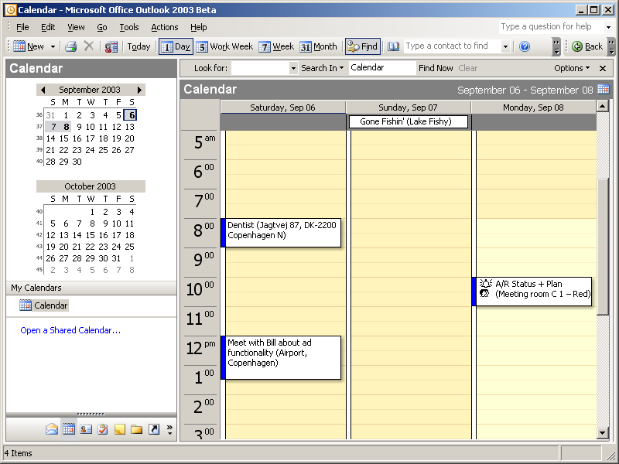
Figure 1 Screenshot of Outlook Calendar

Contacts

Microsoft Outlook integration
Name | MSOutlookContactsService
Description
Effort
Client
Server
References | Microsoft Outlook

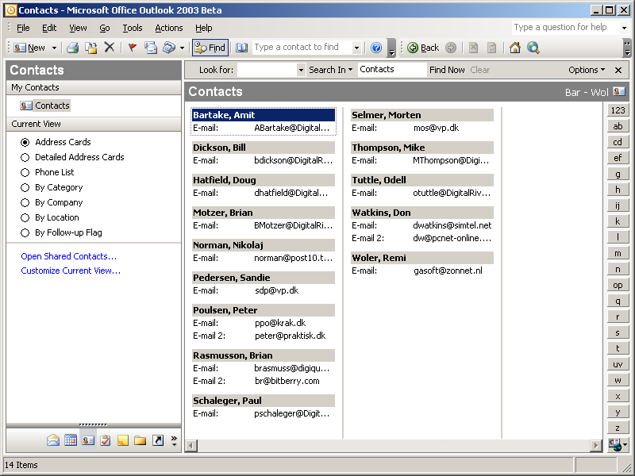
Figure 2 Screenshot of Outlook Contacts

Tasks

Microsoft Outlook integration
Name | MSOutlookTasksService
Description
Effort
Client
Server
References | Microsoft Outlook

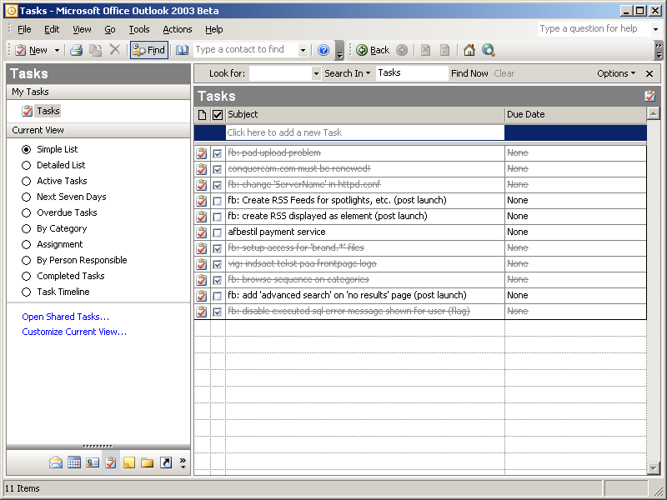
Figure 3 Screenshot of Outlook Tasks

Notes

Microsoft Outlook integration
Name | MSOutlookNotesService
Description
Effort
Client
Server
References | Microsoft Outlook

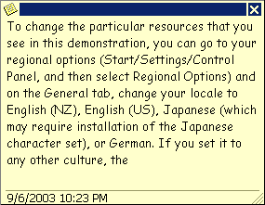
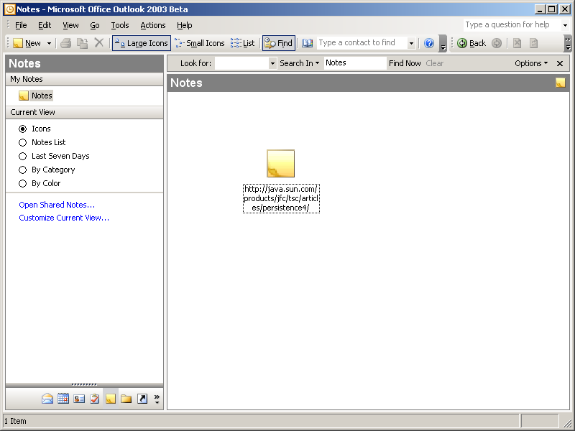
Figure 4 Screenshot of Outlook Notes

Bookmarks

Internet Explorer Favorites
Name | IEFavorites
Description | Bookmarks synchronizer for Internet Explorer.
Effort | Medium
Client | Customized GUI for showing hierarchy of available bookmarks.
Server | None
References | SyncIT

Reading all bookmarks from the Internet Explorer Favorites folder is performed on the client side. Favorites are stored as standard files with a specific format thus a file reader and directory watcher are needed. When a new bookmark is created, the service should see the change and send a create request to Iquomi and if a bookmark is updated by e.g. changing the name an update should be send.

Synchronizing bookmarks doesn’t really need to have a customized GUI since bookmarks can be shown directly in Internet Explorer however it might be an added value for the user to have a list of all bookmarks stored by the service and all bookmarks stored by IE though these ought to be the same.

SyncIT are providing a service for synchronizing both Internet Explorer and Netscape (maybe Mozilla as well?) bookmarks and this company should be approached since they might be interested in moving their service to the Iquomi platform in the future.

Mozilla
Name | MZBookmarks
Description | Bookmarks synchronizer for Mozilla
Effort | Medium
Client | File parsing of known and standardized format.
Server | None
References | SyncIT

The Mozilla browser is storing bookmarks into one large file. This file must be watched and parsed on every update and changes communicated to Iquomi.

Backup
Name | Backup
Description | Back up files from your local hard drive.
Effort | Large
Client | GUI for selecting which files to backup, setting up intervals for auto-backup and watching files backed up on Iquomi.
Server | None
References | IBackup, Xdrive

Existing services such as Xdrive can be improved by offering their users pay-per-transfer licensing models and the ability to use a single-sign on system. Currently Xdrive require a user to enter their email, get a verification mail, register a new account, download an application, install this application and finally log on. Once logged on, it’s possible to backup specific files, setup a schedule, etc.
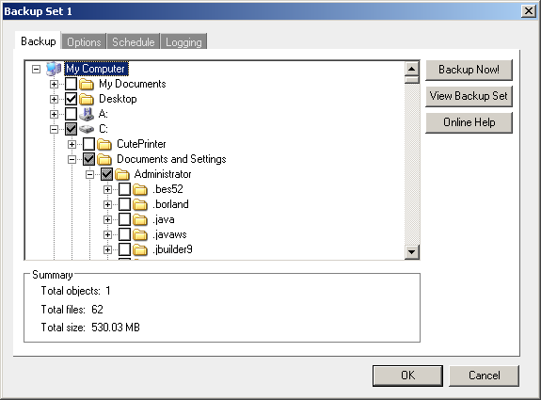
Figure 5 Selecting which files to backup from Xdrive

The application registers as a virtual drive as well allowing users to drag&drop files from Explorer.
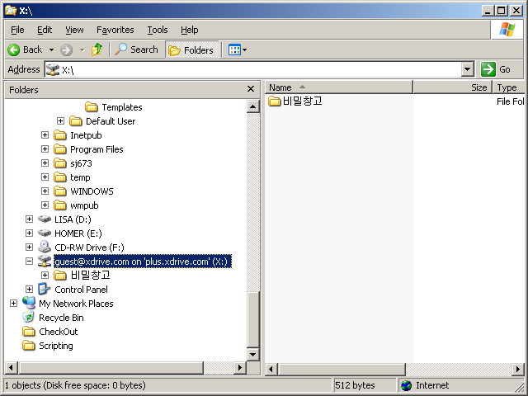
Figure 6 Explorer integration in Xdrive

Xdrive could benefit from the Iquomi platform:
- No specialized account registration procedure needed
- Charge users in a variety of ways such as per uploaded megabyte, per update or per downloaded megabyte
- Send out notification emails when files are changed (workgroup ability)
- No specialized application setup needed

Music collection service

Movie collection service

Messenger service
More and more messengers come with APIs for extending functionality. Integrating it on the Iquomi platform allow these companies to:
- charge per sent message
- storing messages on a distributed system (DCC)
- limit sent messages to a subset of machines (DCC PeerGroups)
- sent notification to listening clients on new messages

Miranda IM
Name | MirandaIMMessageCharge
Description | Charge users for each sent message.
Effort | Small
Client | Miranda plug in instantiating COM object to do Iquomi Object Library access.
Server | None
References | Miranda-IM

The Miranda-IM application is a popular open-source messenger with plug in capabilities for calling standard C++ code. Instantiating a COM object (Iquomi Object Library) would be fairly easy.

Web form filler service
Form fillers are used to keep commonly used web form fields stored on the local machine. When a user enters a page, the form filler pops up and ask if any of the stored information should be used on the page. Form fillers are usually used to keep email, password, first name, surname, address, etc information.

AI RoboForm
Name | AIRoboFormSync
Description | Sync information between online/local repository.
Effort | Small
Client | Plugin for Iquomi client or the ability to call the Iquomi web service from the AI RoboForm application.
Server | None
References | http://www.roboform.com/index.html

This application is one of the best known applications but doesn’t include the ability to keep the stored information on an online repository so if users want to use the form filler on different machines they’ll have to transfer their file from machine to machine.

References

Iquomi Platform Overview

